Samuel Ogunfunmi

This assignment asks you to write the code for a number of functions. You will use your knowledge learned from this week's content to answer the problems in this assignment.

9/13/20

**Problem 1)**

**1. Algorithm (Solution Plan for the Problem):**

1. Create a function called banner
2. Print multiple lines of characters. Together these lines create a banner.
3. Call this function in the main function

**2. Program Source Code (copy and paste from IDE):**

def banner():

""" prints a banner """

print(" _ _ _ ")

print("| | | ||_|")

print("| |_| || |")

print("| _ || |")

print("|_| |_||_|")

def main():

banner() #call function to print banner

main()

**3. Program Output Screenshots/Screen Print(s) and/or Error Messages:**

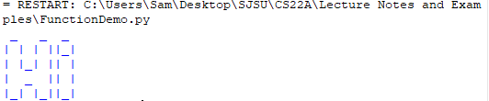

**Problem 2)**

**1. Algorithm (Solution Plan for the Problem):**

1. Create greeting function
2. Print a greeting in the greeting function
3. Ask the user for their name in the main function
4. Call the greeting function to greet the user by name in the main function

**2. Program Source Code (copy and paste from IDE):**

def greeting(phrase):

print("Hello, how are you ")

print(phrase)

def main():

name = input("What is your name? ") #asks user to input name

greeting(name) #prints greetings and user name

main()

**3. Program Output Screenshots/Screen Print(s) and/or Error Messages:**

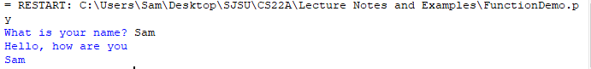

**Problem 3)**

**1. Algorithm (Solution Plan for the Problem):**

1. Create a function for cube
2. Ask the user for input 1 and input 2 in main
3. Convert the inputs to float variables
4. Create variables in the cube function to cube each of the float inputs
5. Add the totals of input 1 cubed and input 2 cubed together
6. Print the sum in the cube function
7. Call the cube function in main

**2. Program Source Code (copy and paste from IDE):**

def cube(x,y):

int1_cubed = x**3 #cubes x

int2_cubed = y**3 #cubes y

cubedtotal = int1_cubed + int2_cubed #adds the cubed values of x and y

print(cubedtotal) #prints the total of x^3 + y^3

def main():

int_1 = input("Enter 1st integer: ") #Input for value 1

x = float(int_1)

int_2 = input("Enter 2nd integer: ") #Input for value 2

y = float(int_2)

cube(x,y) #calls the cube function which prints the cubedtotal

main()

**3. Program Output Screenshots/Screen Print(s) and/or Error Messages:**

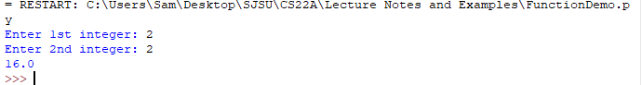

**Conclusion/What you learned writing this program and what problems you encountered.**

I learned how to use functions to greet users, print multi-lined statements, and complete math equations. Some problems I encountered were figuring out how to cube my inputs correctly.